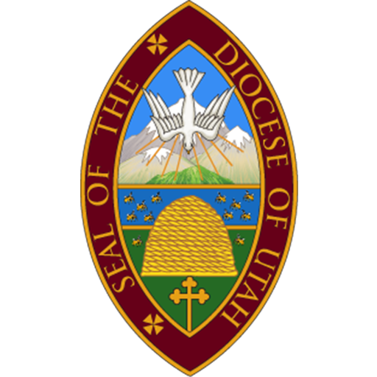
Canon to the Ordinary
Application

Striving towards Becoming God’s Beloved Community, the Episcopal Diocese of Utah commits to being:
“Rooted in Jesus. Joyous in Discipleship. Abundant in Spirit”
Please attach your answers, pasting in the question above each answer.

- Describe an experience of personally learning about Becoming Beloved Community (BBC) and how that learning has affected you both personally and in your ministry. (No more than 700 words.)

- Provide an overview or a lesson plan for an event/class you facilitated around one or more of the BBC pillars.

- Name two aspects of what you consider to be “Episcopal Identity” (e.g., what values do Episcopal Churches hold that might distinguish them from other Christian denominations?) For each aspect, offer an idea of how you might develop that point of Episcopal identity in working with a congregation.

- Why do you feel called to this particular Canon to the Ordinary position? (No more than 500 words.)

- When have you worked in a multicultural setting? What was your role? (Please include the languages that you speak and your proficiency level.)

Send to:
Angela Rogers, Executive Assistant to the Chancellor, arogers@episcopal-ut.org 801-322-4131

